**Spotting fake Journalism**

What is the aim of journalism? How trustworthy journalism is for several news and reports?

Journalism is supposed to be about relieving various news and reports about the happenings across the world and every Nation. They should be true news with supporting stats, facts, and other figures. However, from the past few decades, the meaning of journalism has changed abruptly and spreading Hoax and fake news with sophisticated disinformation worldwide.

On the recent riot in USA for the campaign of ‘Black Lives matters’, Donald Trump came up with a manipulated clip of racist babies on Twitter. It was as fake and unrealistic that even the twitter flagged Trump for the same.

This is how fake news and journalism is conquering every agenda!

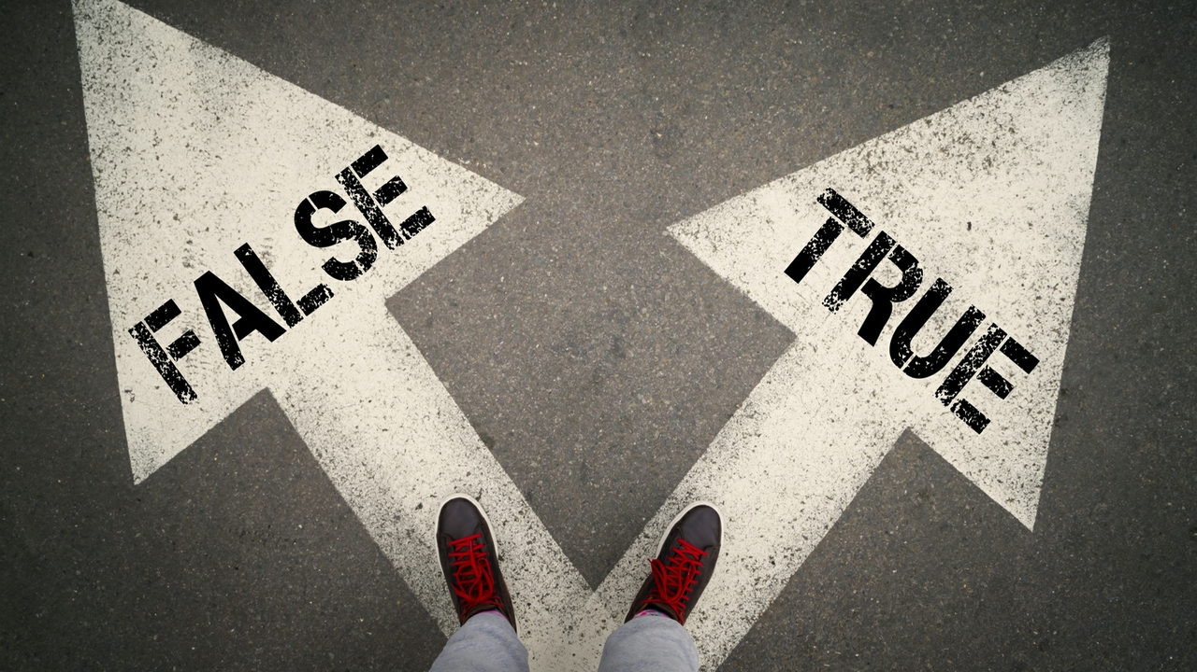

Whether it is about any business, or democracy, or politics, or governments, or any Bollywood or Hollywood news, everything has less reality and more rumors to receive a huge number of audiences for the sources. Such fake journalism and news are published to mislead the public against, or in favor of any agency, people, politics, or any other agenda.

Social media, blogs, online journalism, news portals, and even news agencies make use of this to attract the audience and mislead them with fake stats!

**Identification of category:**

According to Claire Wardle, fake news can be of several types but the topmost practices in today's generation are as follows:

* **Satire** has no intention for harms but it comes with a cause of fooling people.
* **False connections** in which headlines and images do not match the content provided in the news section.
* **Misleading contents** that are used to create an issue and frame any individual or agency for any misdeed.
* **Imposter contents** in which the genuine resources are changed with the false ones making the false ones as the resources.
* **Manipulation** to transform a piece of actual news or information into a manipulated content to misguide the public.
* **Fabricated contents** that are 100% false and are designed to deceive people.

With the identification of the categories of fake news, it is clear that journalism mainly follows the problems of misinformation, disinformation, and mal-information. As in,

* **Misinformation** in which information exhibition is false and does not have any harmful intention for any people or agency.
* **Disinformation** in which harmful intention is there added behind the news.
* **Mal-information** shares general information intending to cause harm to any specific person or agency that is the target.

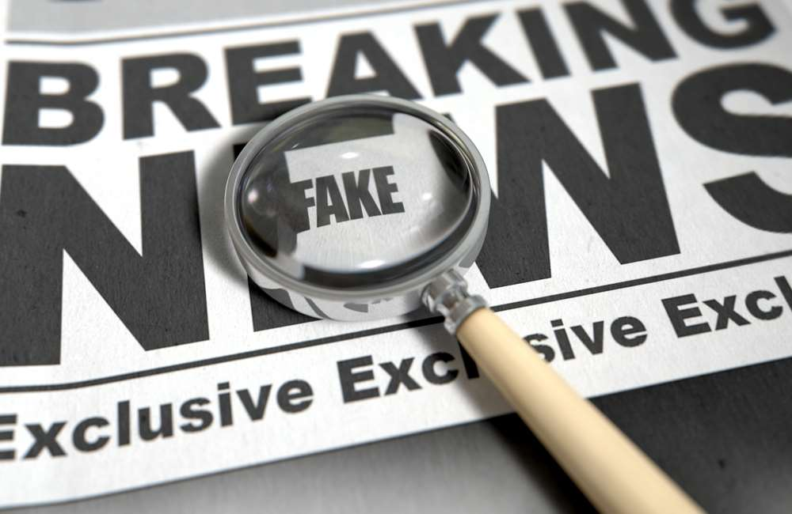

**Spotting fake news:**

However, spotting fake news is not that a big deal, as you just need to be active enough to verify the contents and must be aware of the true resources!

To identify fake news, one must first consider the source and the purpose behind the news, and also the mission of the source that is viewable. Apart from that, you must get an in-depth reading about the news, and not just the headlines, to make sure what the actual news is about. Checking the authors is also a crucial part and one should also have access to supporting sources and check the date of publications as well as the similar news in other resources to tally the contents.

**Fake News in the 21st century:**

In the medieval era, the purpose behind this fake news was to create chaos and anger between several rulers and their dynasties. In the 21st century, however, the trend of fake news has been increasing day by day with the enhancement in internet facilities, and various other advancements to access news anytime and anywhere. Social media influencers play a huge role in promoting and generating fake news and trolls about different people and agencies. The topmost and recent fake news are:

* In 2020, the most recent fake news was with China claiming 40 troops killed in the Galwan clash to seek attention and support. That was fake news about the casualties in the clash!
* Also, various Agencies and medical firms stated that they will be coming out with various Coronavirus vaccines and medicines by August and September, and that is also considered fake as it lacks various stats and facts and also the records on how the testing is going on when it started, and when is it good to end.
* There has been news that Vladimir Putin is using lions to control lockdown around Russia, and that came out to be fake news, and just a joke created by Twitter.

**Maintaining trust, an issue with fake news!**

With various false information and misleading content, the public seems to have lost trust on Journalists and their agencies to have a piece of true information. The government needs to keep a check on false journalism and maintain public trust towards news sources to help them stay aware of various global happenings.